**MSK PHYSIOTHERAPY SELF REFERRAL FORM**

Self Referral is a direct route to physiotherapy. Physiotherapy can help with a range of problems including back pain, neck pain, recent injuries, strains, sprains, joint and muscular pain.

This referral option is NOT available to under 16s, or for neurological, respiratory or gynaecological problems or if you are still under the care of a consultant. Replacement splints and aids cannot be supplied. Please consult your GP in this instance.

**Personal details**

Title Mr / Mrs / Ms / Miss / other ………………………………………………………………………………………

Surname ……………………………………………………………………………………………….………………………………

Forename ………………………………………………………………………………………….………………………………….

Date of Birth ……/……./…...

Address including Post Code ………………………………………..……………………………………………………….

………………………………………………………………………………………….……………………………………………………

Mobile number…………………………………………………………………….………………………………………………..

An SMS Text consent/reminder form is available at our reception or online.

Home/Work number ……………………………………………………………..………….………………………………….

Your GP Surgery…………………………………………………………………………………….……………………………….

**Please choose a location you would like to be treated** (Port Erin and Ramsey have limited availability). Indicate 1st and 2nd choice

Community Health Centre, Douglas ………………………………………….

Ramsey and District Cottage Hospital, Ramsey …………………………

Thie Rosien, Port Erin ………………………………………………………………..

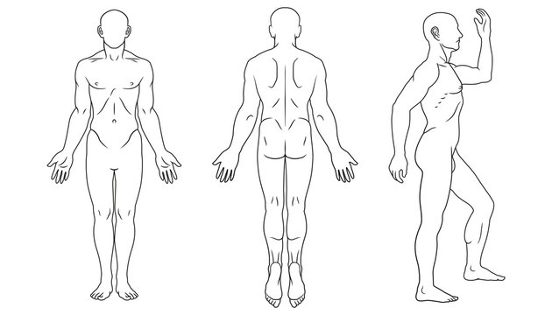Please indicate where your pain problem is and briefly describe your symptoms

…………………………………………………………………………………..

……………………………………………………………………….............

…………………………………………………………………………………..

…………………………………………………………………………………..

…………………………………………………………………………………..

Patients with low back pain if you are experiencing any of the following **please contact your GP immediately:**

- Altered sensation between your inner thighs/genitals/anus  
- Difficulty trying to urinate  
- Poor control when passing urine, or leaking urine  
- Unable to tell if bladder is full or empty  
- Inability to stop a bowel motion  
- Change in ability to achieve orgasm

Is there anything else you think we should know about your health or situation, previous surgery, medical conditions or pregnancy etc.? …………………………………………………………………

………………………………………………………………………………………………………………………………………….

On average, how intense is your pain (0 is no pain and 10 is pain as bad as it can be)

|  |  |  |  |  |  |  |  |  |  |  |
| --- | --- | --- | --- | --- | --- | --- | --- | --- | --- | --- |
| 0 | 1 | 2 | 3 | 4 | 5 | 6 | 7 | 8 | 9 | 10 |

Thinking of the last 2 weeks please complete the questions below:

|  |  |  |
| --- | --- | --- |
|  | Yes | No |
| 1 do you often feel unsure about how to manage your pain condition |  |  |
| 2 over the last 2 weeks, have you been bothered a lot by your pain |  |  |
| 3 have you only been able to walk short distances because of your pain |  |  |
| 4 have you had troublesome joint or muscle pain in more than one part of your body |  |  |
| 5 do you think your condition will last a long time |  |  |
| 6 do you have other important health problems |  |  |
| 7 has pain made you feel down or depressed in the last 2 weeks |  |  |
| 8 do you feel it is unsafe for a person with a condition like yours to be physically active |  |  |
| 9 have you had your current pain problem more than 6 months |  |  |
| Total |  |  |

Signature…………………………………………………………………………………….. Date …… / …… /………….

Please sign and return the form to: **Out-Patient Physiotherapy Department, Community Health Centre, Westmoreland Road, Douglas, IM1 4QA**

Please allow one week from posting before contacting us on **624119 between 8am and 10am to book an appointment**. If we have not heard from you after 3 weeks you will be automatically discharged from the service.

**What if I am unable to attend my appointment?**

Please let us know at least 24 hours before your appointment. You can phone **642158** to reschedule your appointment if needed.

Patients who have a high temperature, new cough, cold, diarrhoea, vomiting or any other infectious condition are advised NOT to attend their appointment but to contact reception on **642158** to advise and rebook when they are clear of symptoms.

**Do I need to bring anything to my appointment?**

**Appropriate clothing** - we need to see the area of your symptoms, eg, shorts for a knee or ankle problem, or a vest top for a neck or shoulder problem. **Glasses** if needed and a list of your **Medication.**

**(Gregor please can you add in what we need to say with regard to data sharing and consent etc)**