Ramsey Group Practice
Bowring Road
Ramsey
IM8 3EY
Tel :01624 813881

Home visit Policy

Ramsey Group Practice home visit policy
The purpose of this policy is to provide guidance for staff and assurance to patients that Ramsey Group practice is committed to continually providing high quality healthcare for all patients and supporting the staff that provide this care. The aim of the policy is to outline the practice’s policy on home visits.

Scope
This policy applies to all employees ofRamsey Group practice, contractors, seconded staff, placements, and agency staff.

Roles, rights, and responsibilities

All staff
All staff areresponsiblefor following the requirements detailed in this policy.

Practice manager
To update the policy, ensure that it is aligned with national guidelines, distribute appropriately, and ensure that staff are trained at induction and at regular intervals so that they are aware of the content of thehome visit policy.

Principles of this policy

Distribution
Employees will be made aware of this policy viaTeamNet.
Patients will be made aware of this policy on the practice website.

Training
All staff will be given training on the policyat induction and at regular intervals thereafter.
Any training requirements will be identified within an individual's PersonalDevelopment

Equality and diversity impact assessment
In developing this policy, an equalities impact assessment has been undertaken. An adverse impact isunlikely, and on the contrary the policy has the clear potential to have a positive impact by reducing andremoving barriers and inequalities that currently exist.
If, at any time, this policy is considered to be discriminatory in any way, the author of the policyshould be contacted immediately to discuss these concerns.

Monitoring and reporting
Monitoring and reporting in relation to this policy are the responsibility of the practice manager.
The following sources will be used to provide evidence of any issues raised:
- PALS.
- Complaints.
- Significant and learning events.

Source of information
Our home visit policy is based on the GMS contract, local LMC guidance, BMA guidance and medico-legal advice

Limitations on home visits
- Home visits are time consuming.
- Limited diagnostic equipment that would normally be available in the surgery
- Several patients can be seen in the practice in the time that it takes to make one home visit.
At Ramsey Group practice every effort is made to facilitate patients visiting the surgery whenever possible.

Home Visits are reserved for the following groups of patients:
- Terminally ill
- Housebound
- Patients who are severely ill in bed

Process for requesting a home visit
- All home visit requests should be received before 11am unless in emergencies
- The request is received by the administrative staff whowill place this onto a visit list.
- The request will be screened by pharmacy technician, prescription/medication or non-clinical queries will be dealt with at this point and actioned to the Patient’s named GP
- The Paramedic Practitioner will triagethe request for necessity and urgency and will be allocated to the most appropriate clinician as appropriate.
- In some situations the request may be passed to another member of the community team e.g. District Nurse
- Home visits are at the discretion of the triaging clinician who will determine if the visit is clinically necessary

The following ARE NOT valid reasons to perform a home visit:
- Transport issues for the patient
- Poor mobility
- A unwell child (If a parent believes that the child is too unwell to travel to surgery, and is a medical emergency then it would be advisable for them to seek help from the emergency services by calling 999)
- Poor weather conditions
- All Residents of care homes (Care home residents are no different to patients in their own homes. The need to visit should be based upon clinical need, not the availability of transport or staff to attend the surgery. It is the responsibility of care facilities to make transport available for residents so that they can get to medical and non-medical appointments.
- Any other situation deemed inappropriate by the clinician

Home Visit algorithm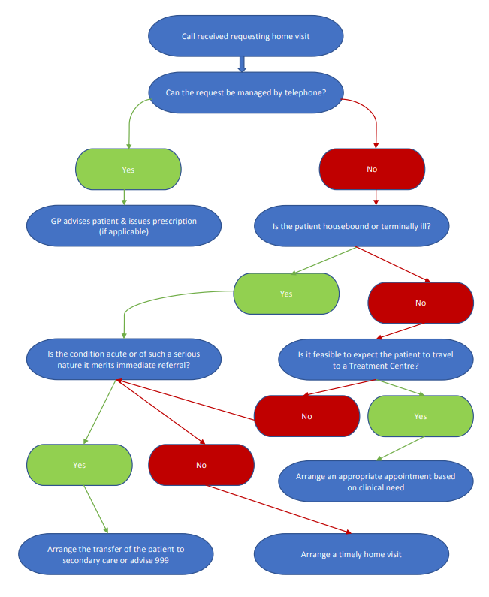

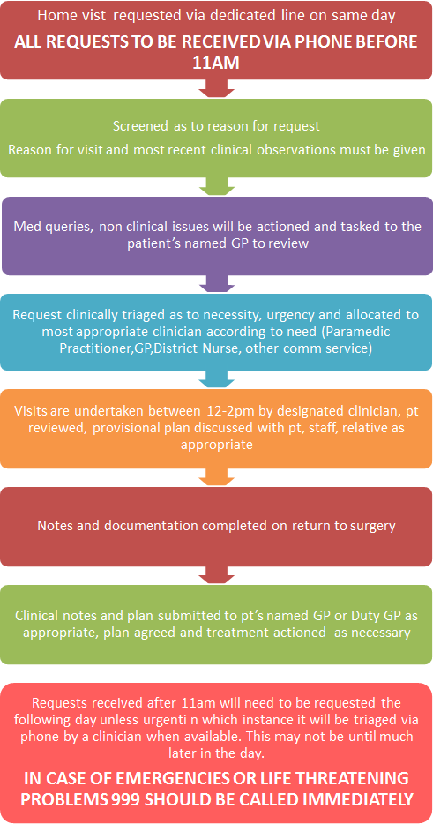

Versions
Document review history
Version number | Author/reviewer | Summary of amendments | Issue date
1.0 | Dr Maitiu O Tuathail | Policy modified for Ramsey Group Practice | 19.5.2021
2.0 | A. Fisher | Policy amended as per new process | 19/05/2022

